|  |
| --- |
| 2014 IT Code Fair |
|  |
| The inaugural IT CODE FAIR was held November 14, 2014. This document provides an overview of the event and lists decisions made through consultations with staff, students and industry about the continuation of the event in 2015. |
|  |

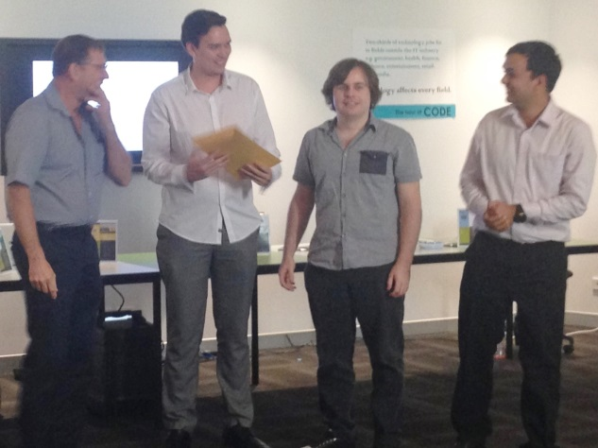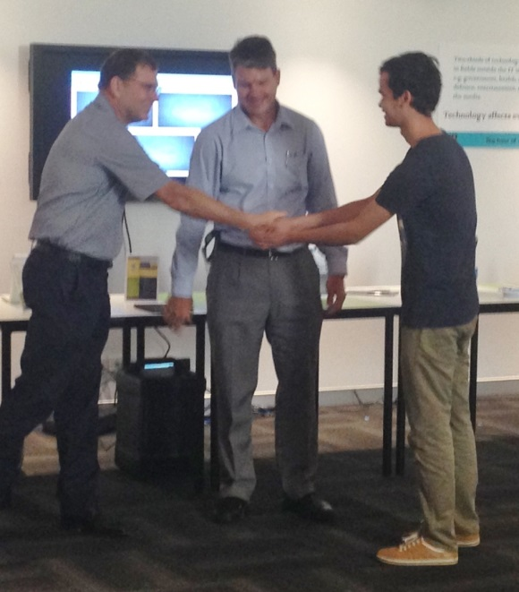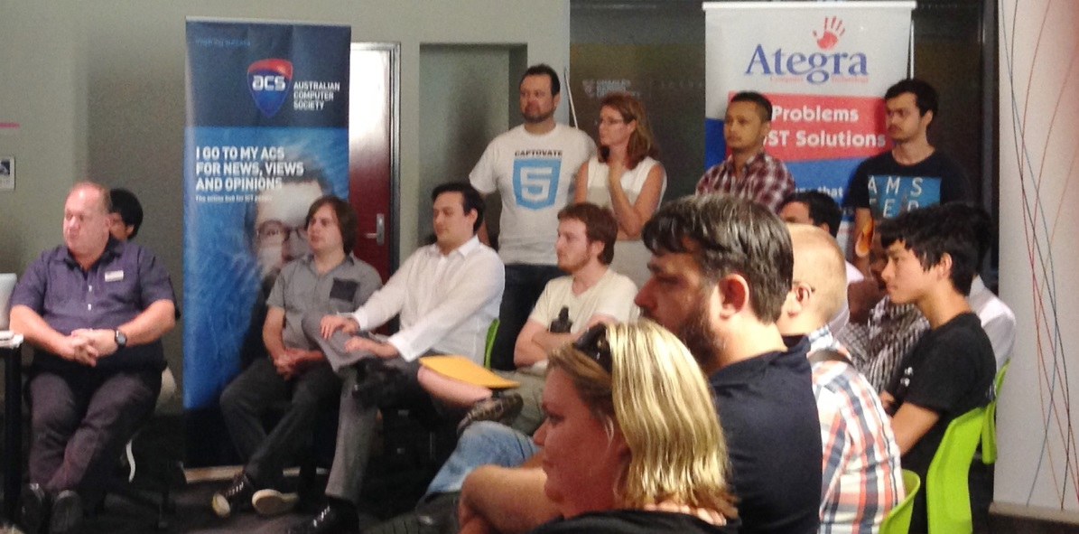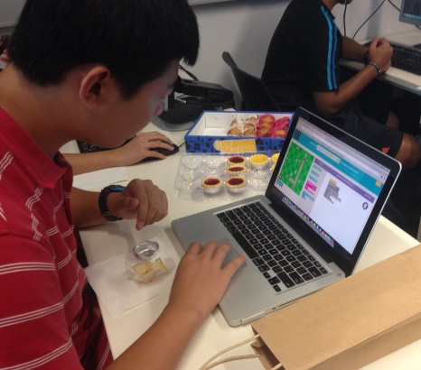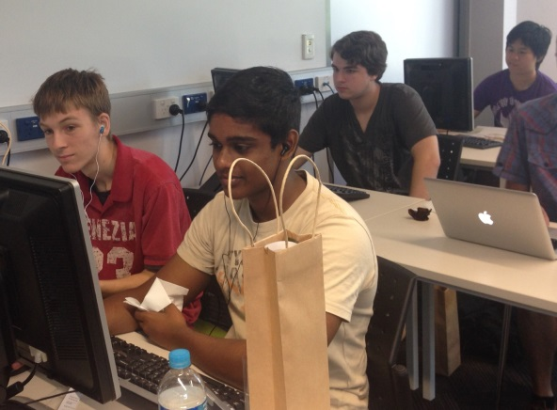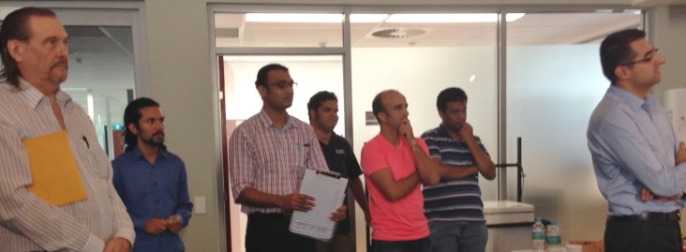

2014 IT Code Fair

## Introduction

The development of new courses in Information Technology at Charles Darwin University has brought greater attention to the role of coding in the discipline. With a Masters in IT (Software Engineering), a Bachelor of Software Engineering and the Bachelor of Information Technology, students now have many more opportunities to build software products: applications, databases; mobile and responsive web sites and apps.

To encourage and support students’ coding development a code fair was organized to enable students to showcase their work developed during the year more broadly within the University and industry community while reaching out to the secondary school community.

## Code Fair Events

The Code Fair included three major activities:

1. Coding competition

The competition was open to all 2014 IT students who had created apps; programs; mobile prototypes, websites, games that demonstrate their developing knowledge, skills in building elegant, maintainable code that works.

18 students submitted 20 examples of their work. Students were judged by a panel of industry judges in categories associated with their level of study: Post graduate individual and group; Undergraduate individual and group. Prize winners are listed opposite.

2. Promoting code as the new literacy: workshops for school students

Supporting the global ‘Hour of Code’ initiative to develop coding literacies, three x one hour workshops were run for two local schools (Lutheran Christian College Year 9’s and Darwin High Year 10’s) and 15 university staff. Feedback from students and staff was very positive and supportive. See: http://rengland.spinetail.cdu.edu.au/hoc/

# Prize Winners

• • •

#### Innovation

* PG: *Stenography*

(Pankaj Kashyap

Kanwarpreet Singh

Navpreet Kaur)

* UG: *Chitty Chat*

(Farzand Ali; Aden Herold; Joseph Packer)

(Sponsors: Dolphin)

#### Masters

* Individual: Ling An Lin

(Sponsor ACS)

* Team: Navpreet Kaur; Kanwarpreet Singh; Pankaj Kashyap

(Sponsor Radical Systems)

#### Undergraduate

* 3rd year Individual: Richard Deveraux

(Sponsor Dialog)

* 2nd Year Individual:

(Tie) Robert Jackson

(Sponsor Dialog)

Bidhan Neupane

(Sponsor Kinetic IT)

* Highly Commended:

Roy Galet

(Sponsor ACS)

* Team: (Farzand Ali; Aden Herold; Joseph Packer)

(Sponsor Kinetic IT)

Asdfasf

3. Industry Employer Speed Dating

# Industry Sponsors

• • •

School of Engineering & Information Technology would like to thank the following IT businesses for their sponsorship:

* Ategra
* Australian Computer Society
* Dialog
* Dolphin Software
* Kinetic IT
* Radical Systems

Thank you to industry who participated in Speed Dating

* Ategra
* Captovate,
* CDU, ITMS
* Dash Media
* Dialog
* Dolphin Software
* Kinetic IT
* MIP
* Radical Systems
* Relatonal Data Systems
* SRA

Thank you to industry who provided judges:

* Ategra
* Dash Media
* Dialog
* Dolphin Software
* Kinetic IT
* MIP
* Radical Systems
* Relatonal Data Systems
* SRA

Graduating Masters and Undergraduate students and students needing work placements were given an opportunity to meet 11 local employers in the Speed Dating event. Twenty places were available and 17 students took up the opportunity (9 Masters students & 8 UG students). Students had one minute to pitch their skills and achievements and employers had 2 minutes to ask questions before the students moved on to the next employer.

Feedback from students involved indicated that some were offered placements; work and work experience from this speed dating event. Other students commented: It was special day for me, i learned and understood the employers' expectations. Now, it is time for me to prepare and improve skills to meet those requirements.

# Code Fair 2015

Consultations were held with staff, students and industry with a view to decide whether to hold the event again, and if so in what form: what could be improved, changed, adapted?

## Decision 1: Event to be held 2015, November 20

Feedback from most people involved indicated that the event was successful and should be held again. Feedback from students indicated that two weeks after the end of the exam period would be more suitable, hence the date above. Industry was happy to support the time and this date also works for extending the event to include the VET IT students and staff.

CDU VET IT have indicated that they would be happy to be involved in 2015.

## Decision 2: Include a 24 hour coding challenge as part of the code competition

Strengths identified for the first event included:

* Number, quality and diversity of entries were commendable
* Engagement of students with the judging competition also commendable
* General layout worked but requires more finessing due to sound issues.
* High school students very interested in the CDU student work
* Venue decoration and layout worked well – the balloons are a great idea
* The enthusiasm and energy of the judges was inspiring
* Food & drink appropriate for the event

Areas that could be improved include:

# 24 hour Coding Challenge

• • •

* Industry developed – single project that students have 24 hours to respond with a solution.
* Specifications will e provided
* Students can respond as team or individual
* Solution & process are part of the challenge.
* Students will need to show how they used the time: requirements, design & development process & solution
* Students need to communicate their decision making and outcomes in a 1 minute elevator pitch.
* All VET /HE IT students eligible to enter
* Think about developing judging categories based on different types of coding development
* Set up software displays so that the sound is better regulated
* Include QR codes on the signs for videos to be viewed while waiting to discuss code with students
* Prizes need to be more organized: consider prizes direct from industry

Coding competition for 2015 should:

* Include a 24 hour coding challenge – see opposite
* Include Student completed work during 2015
* Have categories for the type of work undertaken (web; database etc)
* Require code to be submitted earlier with non disclosure form to ensure easy judging
* Extend competition to design so that there is also a poster competition for work done during the year.
* Manage the number of entries so there is no more than 30
* Organise prizes earlier.
* Begin at 9am.
* Provide an opportunity for judges to provide general feedback to coding students
* Carefully manage the judging timeframes

## Decision 3: Continue with the Code Hour

Strengths identified for the code hour included:

* Students highly engaged
* Materials developed worked well with both students and staff
* Important to have a diversity of students, not just boys.
* Brown paper bag takeaways for students worked really well

Areas that could be improved include:

* Possibly extend to other high school groups
* Allow more time for students to engage with coding competition
* Perhaps consider a larger venue

Coding competition for 2015 should:

* Continue to use similar materials
* Schedule the visits of students to include looking at the coding entries
* Continue with the gift packs to encourage coding after the event.
* Think about student helpers and how they could participate/run some of the sessions.

## Decision 4: Extend Employer Speed Dating to software and hardware

Strengths identified for the employer speed dating included:

* Concept is ‘awesome’ – worked well.
* Students and employers both agreed great opportunity to make contact.
* Very positive feedback from industry and students
* Number of applicants (20) was about right
* Photo information handouts useful
* Timing was about right (1 minute/2 minute)
* General concept and layout was ok.
* Students who had had some preparation were obvious

Areas that could be improved include:

* Find a timer that is accurate with sound to help manage the change overs
* Start the timer once everyone has moved on.
* Provide information on students earlier
* Organise student information in alphabetical order for ease of access.
* Include students who are not only coders – employers have other needs as well; and include VET students

Employer Speed Dating for 2015 should:

* Include VET & HE students in two categories: hardware and software
* Include only students who are prepared to do the preparation
* Remain open for 20 students only (link to industry participants) .
* Provide information on applicants 24 hours earlier in alphabetical order.
* Use a better, louder timing system.
* Think about the spacing of the speed dating set up – may need a little more space between people.